After watching the *What is a Triangle?* video, take a closer look at the problems from the video and become aware of the difficulties children often have when learning to indentify triangles. Discuss the triangles shown in the video to help your child develop an understanding of triangles.

**Problem:** *Skylar is delivering pizzas. He is amazed at how many math discussions he gets into while out making deliveries. He often finds himself talking about his favorite shape, triangles! He is surprised at how many customers just aren’t sure how to tell if a shape is a triangle. Help Skylar and his friends determine a test for checking whether or not a shape is a triangle.*

**Skylar asks his customers the following question: What shape is a slice of pizza?**

Many children say a slice of pizza is a triangle because it “looks like” a triangle. There are a lot of shapes that look like triangles, but many of them are not. Every triangle has key characteristics. A triangle must have three straight sides and the sides must be linked end-to-end.

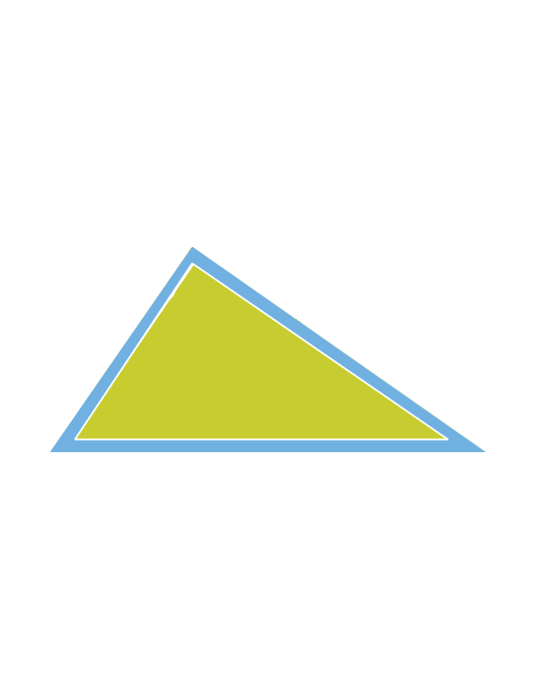

1

2

3

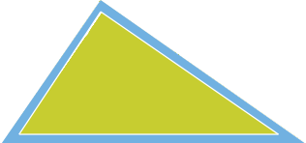

**3 straight sides linked ends**

**Many children think a triangle must look exactly like the following triangle, which is an equilateral triangle sitting on a base.**

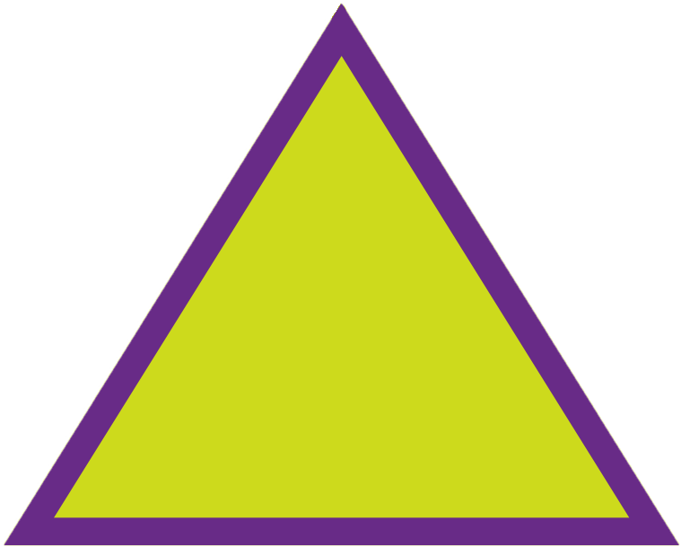

If you turn or rotate the shape, children might say the shape is not a triangle. Help your child put these triangles to the test. Count the three straight sides and talk about how the sides are linked end-to-end.

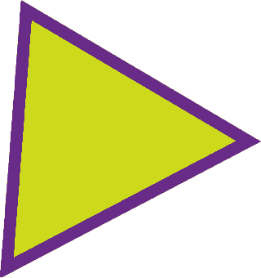 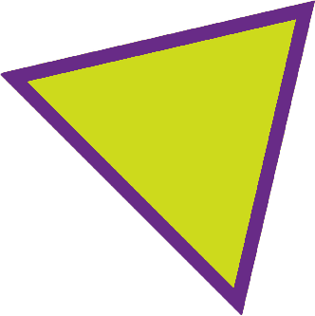

**Many children do not think the following shapes are triangles because the three sides are not the same length.** Again,help your child put these triangles to the test. Indentify the three straight sides linked end-to-end.

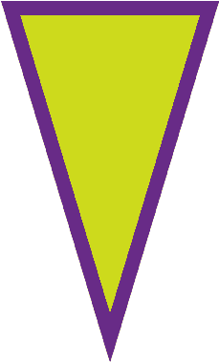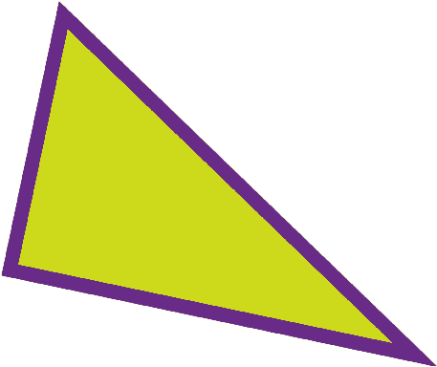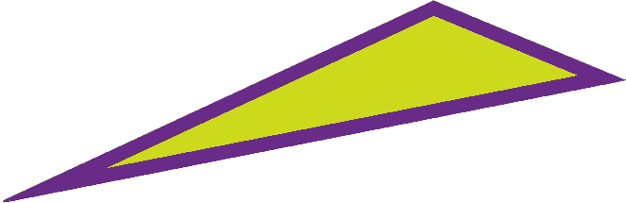

**The following shapes are not triangles, but children might say they are triangles because they “look like” triangles.** Encourage your child to put these triangles to the test by counting the sides. Since there are more than three sides, the shapes are not triangles.

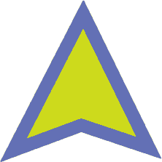 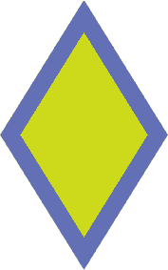 

**Here are three more shapes that children may think are triangles because they seem to have three sides.** Count the sides with your child. Then discuss what it means to have three *straight* sides and identify where the sides curve. The following shapes are not triangles even if they “look like” triangles.

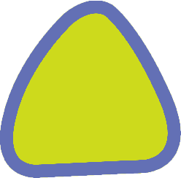 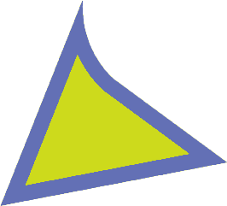 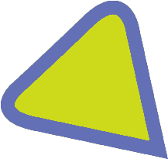

**Now, back to a slice of pizza. Ask your child if the slice of pizza shown below is a triangle.** The slice of pizza has three sides, but not all of the sides are straight, so it is not a triangle.

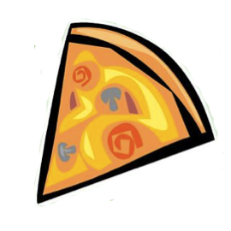

**In addition to having three straight sides, the sides of the triangle must be linked end-to-end.** Many children think the following shapes are triangles, but they are not. Ask your child why the following shapes are not triangles.

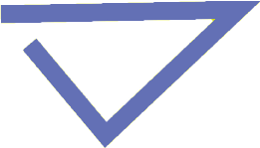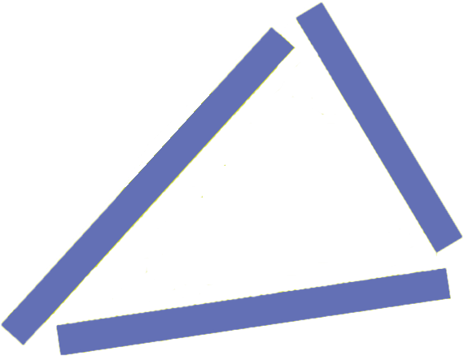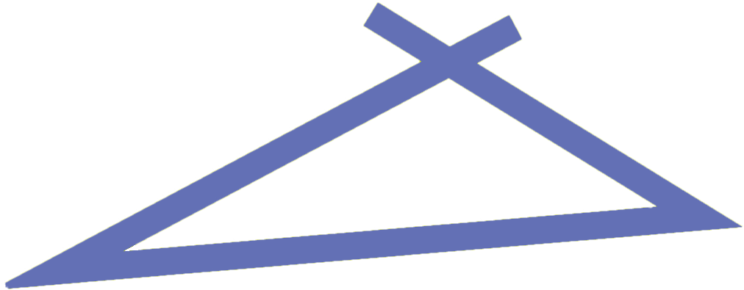

**Along with having three straight sides linked end-to-end, triangles also have three points, called vertices.** If a shape has 3 straight sides linked end-to-end, it will also have three vertices and three angles. Help your child count the number of vertices of different shapes.

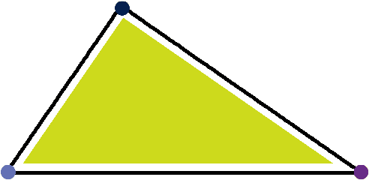 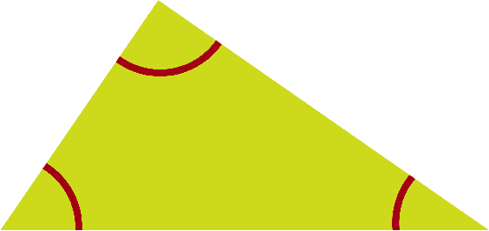

**When Skylar is out making deliveries, he sees all sorts of shapes and puts them to the test to see if they are truly triangles.** Ask your child if the following shape is a triangle. It is not a triangle because it has rounded corners. The sides are not straight where they meet.

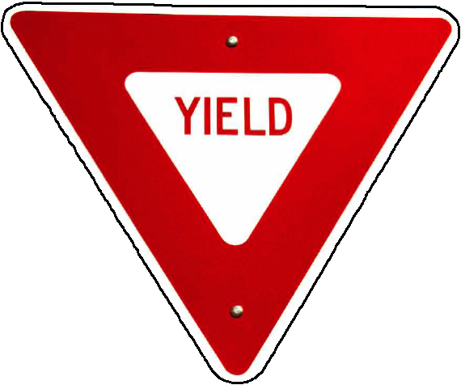

**Now talk about this window with your child.** It has three straight sides linked end-to-end, so it is a triangle.

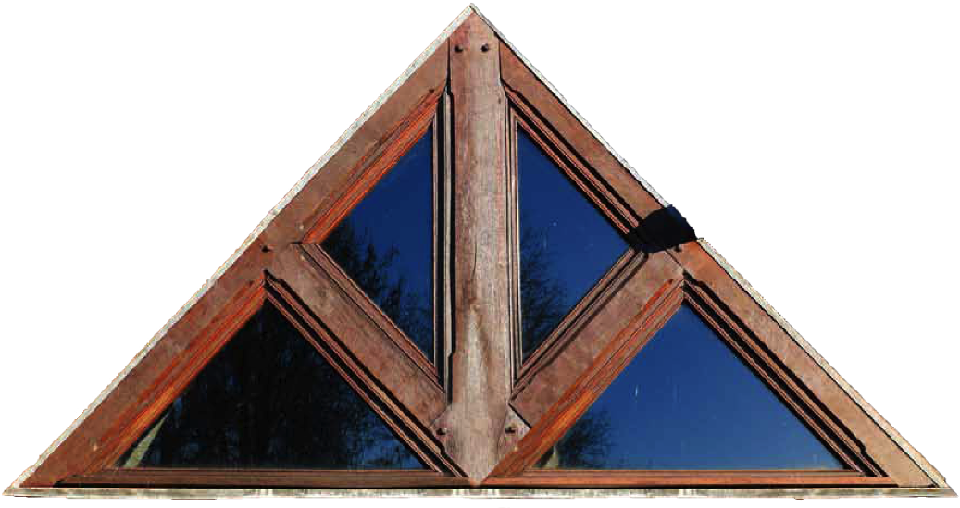

In fact, there are several triangles.

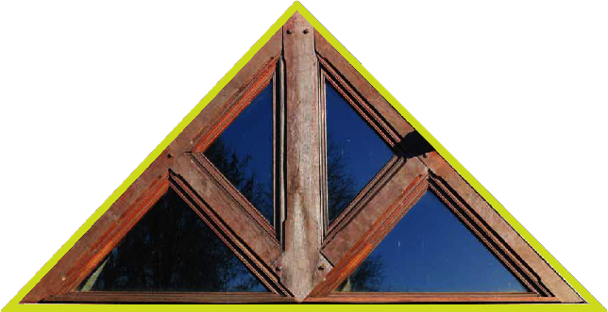 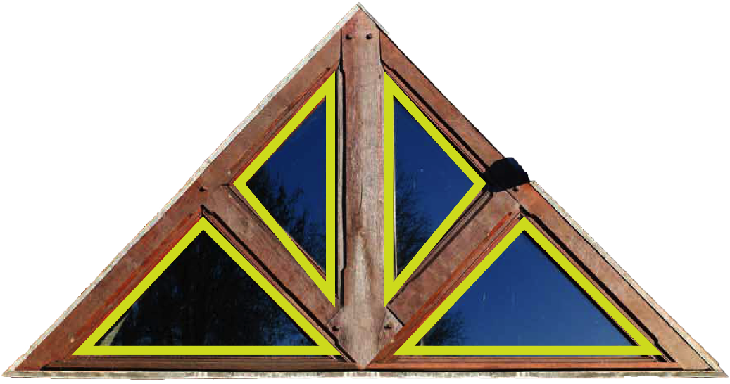

**This musical instrument is called a triangle, but is it really a triangle mathematically speaking?** Mathematically it’s not a triangle because two of the sides are not linked end-to-end, and the sides are not straight where they meet.

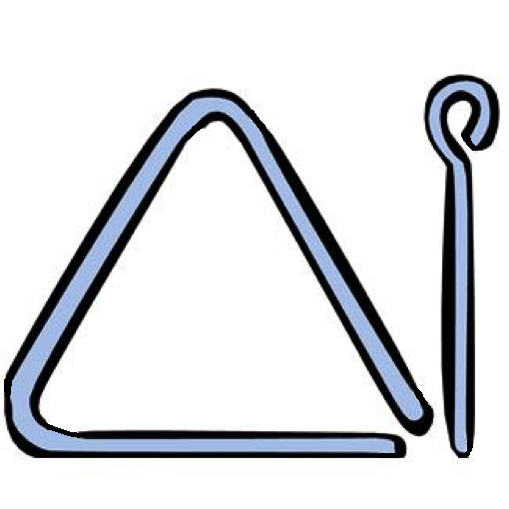

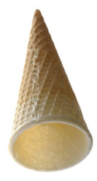**Ask your child what the following item looks like.**  It looks kind of like a triangle, but it is actually a three-dimensional shape called a cone.

**Ask your child to put this shape to the triangle test.** Each face is a triangle, but they come together to form a three-dimensional shape called a pyramid.

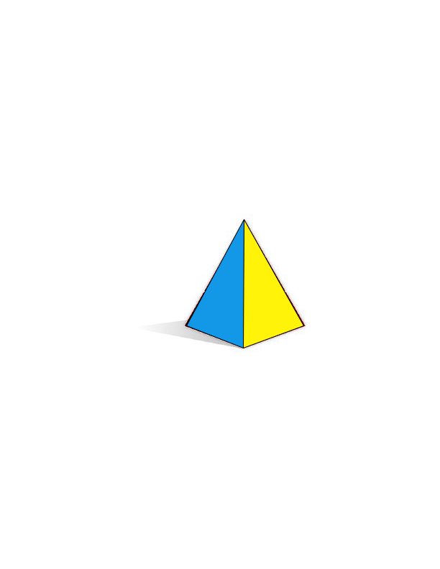

**Be careful when looking at pictures of three-dimensional shapes.** When we see pictures of three-dimensional shapes, they may look two-dimensional. Help your child understand that a key difference between triangles and cones or pyramids is that triangles are two-dimensional or flat, whereas cones and pyramids are three-dimensional.

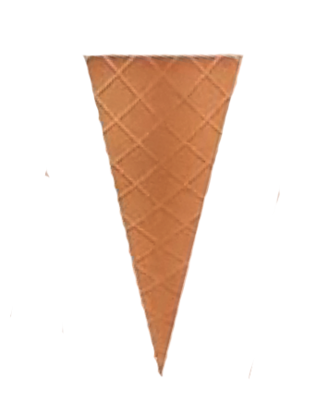

Whether or not a shape is a triangle is based on the following characteristics. The shape must have three straight sides linked end-to-end. This means triangles are two-dimensional shapes and are closed. Many children do not think a shape is a triangle unless it has three equal sides and sits on a side (rather than a point). Many children also think non-triangular shapes are triangles because the shape “looks like” a triangle. Spend time looking around your home and neighborhood. Help your child understand why a shape is or is not a triangle by identifying lots of examples and non-examples.